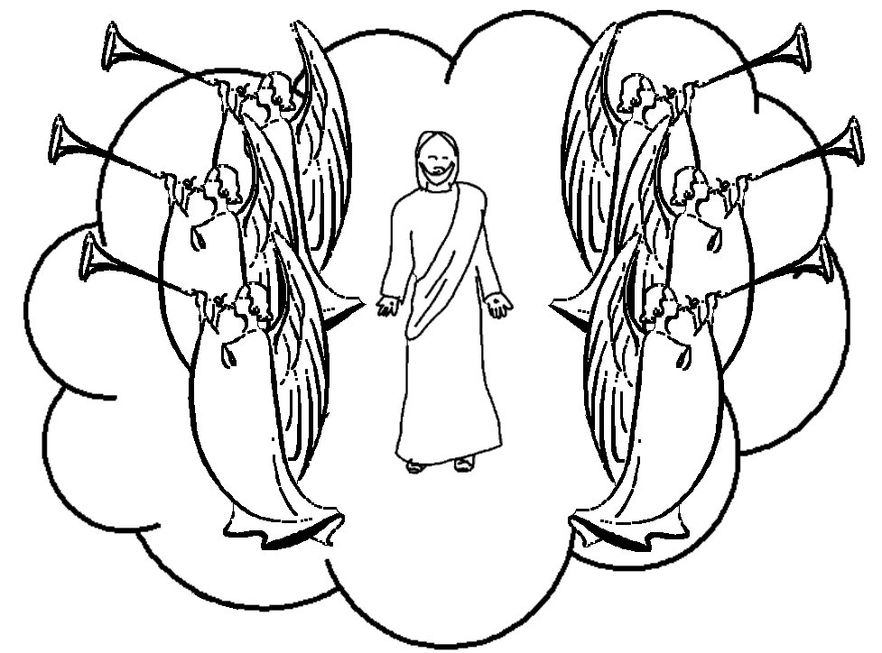

Jesus has been taken from you into _ _ _ _ _ _,
but someday He will _ _ _ _ _ _ from heaven in the _ _ _ _ way you saw Him go!”
Acts 1:11 _{NLT}

